**Signals and Systems**

**Lab – 2**



**Submitted by: Maaz Habib**

**Registration No.: 20PWCSE1952**

**Class Section: C**

“On my honor, as student of University of Engineering and Technology, I have neither given nor received unauthorized assistance on this academic work.”

Submitted to: Maam Dur-e-nayab

May 4, 2021

Department of Computer Systems Engineering University of Engineering and Technology, Peshawar

**Task 1:**

Write a program to generate a new matrix B from the matrix A given below such that each column in the new matrix except the first one is the result of subtraction of that column from the previous one i.e., 2nd new column is the result of subtraction of 2nd column and 1st column and so on. Copy the first column as it is in the new matrix.

13 6 9

A = 1 4 8

2 8 17

**Code:**

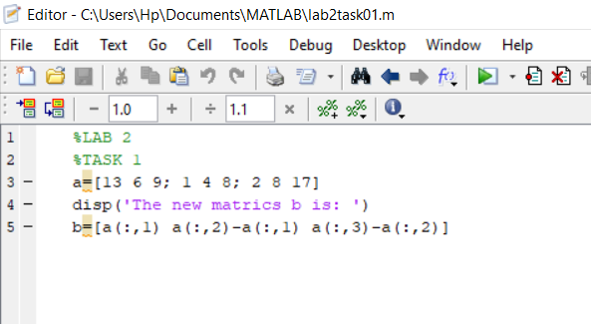

**Output:**

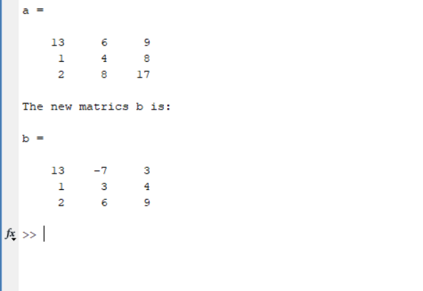

**Task 2:**

Generate two 2500 sampled random discrete time signals (1 dimensional) using rand () function i.e. rand(1, 2500). Write a program to add the two such random signals together using simple vector addition.

Code:

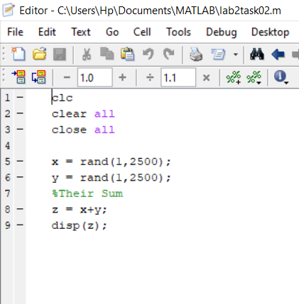

**Output:**

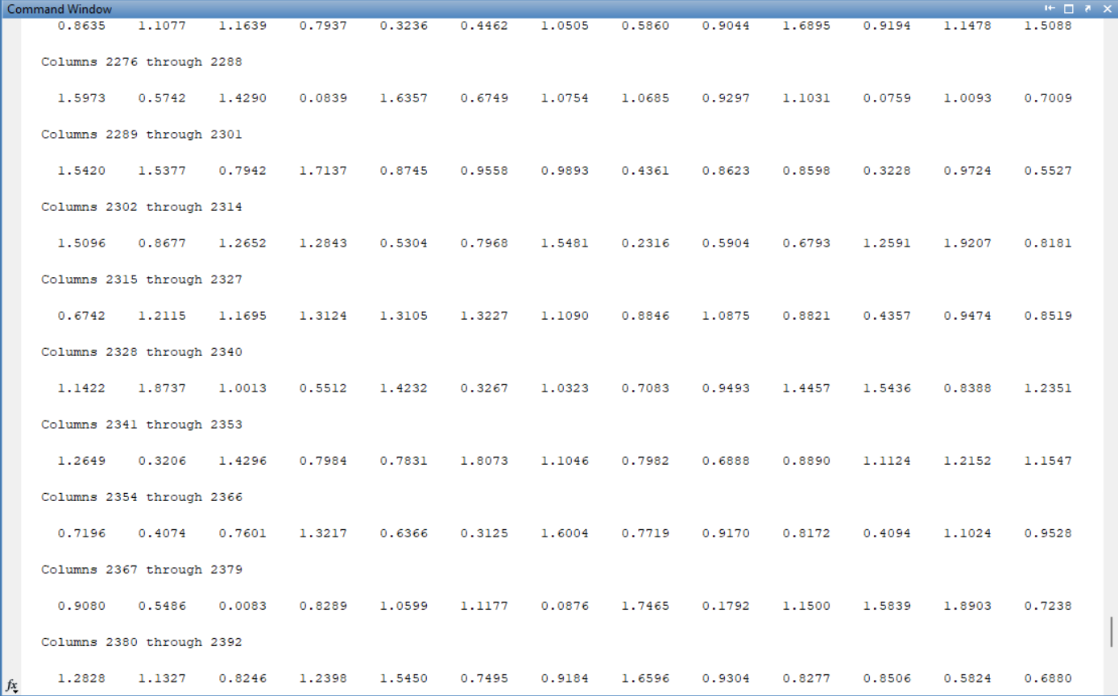

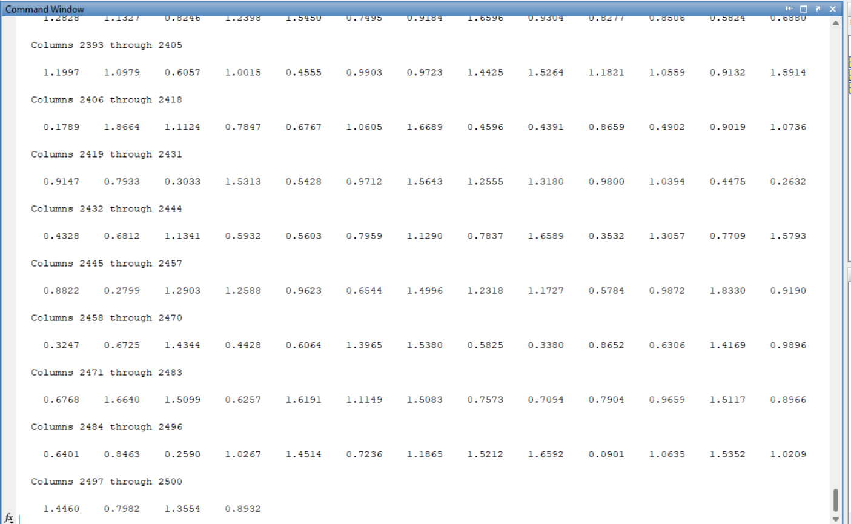

**Task 3:**

Using colon notation, generate the following sequence: -65.25, -57.75, -50.25. . . . . . . . . . ., 54.75,62.25, 69.75

**Code:**

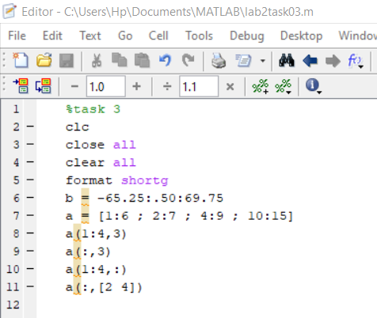

**Output:**

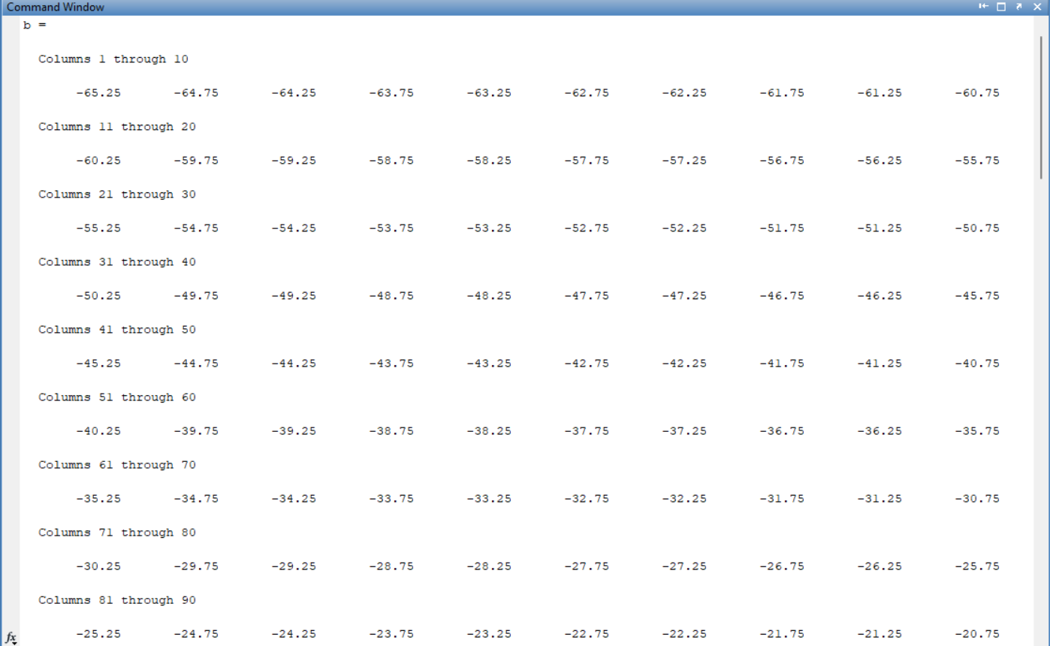

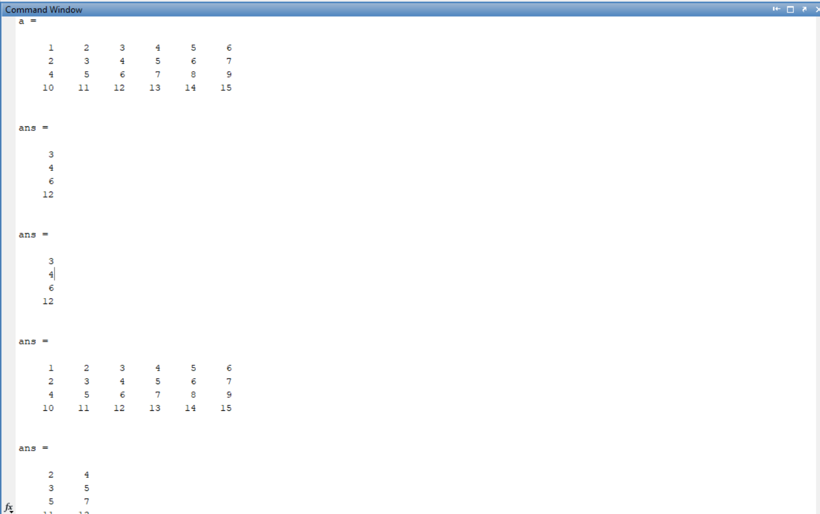

**Task 4:**

Given the matrices:

A=[-12,34,61,-9;65,78,90,12; 14,78,45,12; 60,25,3,8] B=[34,67,8,9; 12,-91,12,9; 89,-8,0,2; 16,9,23,67]

Find the following:

**Code:**

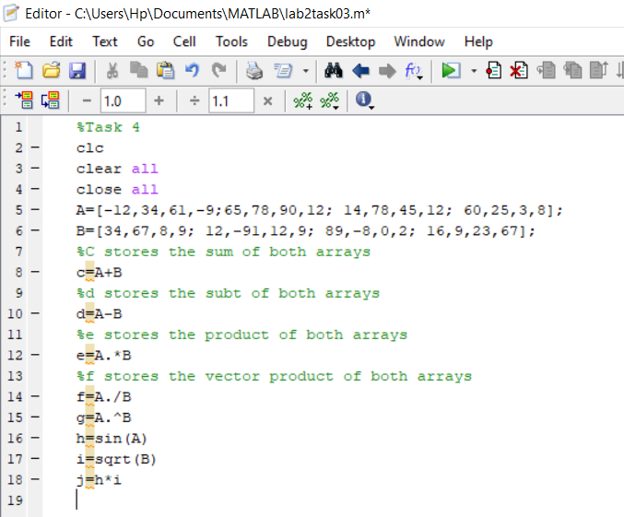

**Output:**

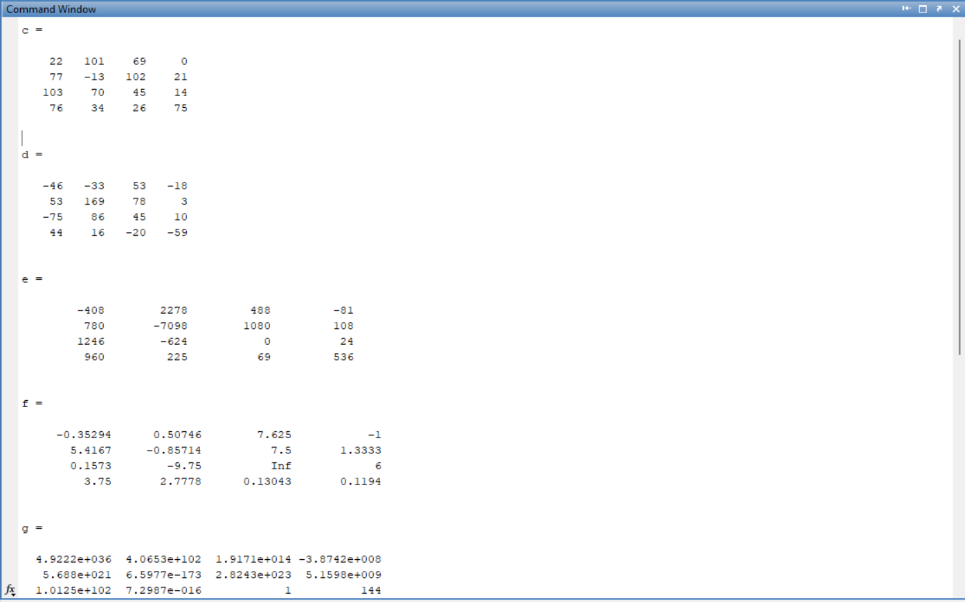

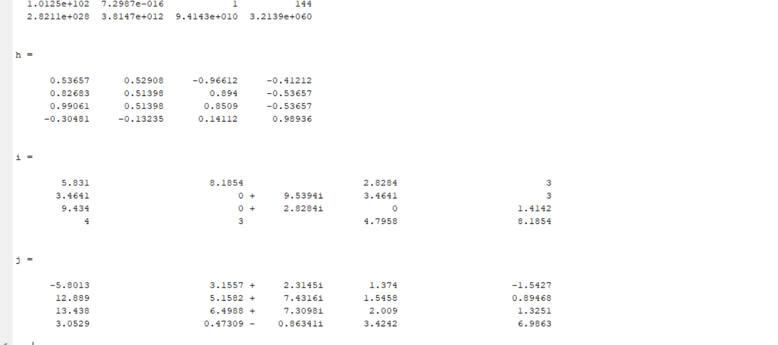

**Task 5:**

Type the given matrix in matlab:

3 7 − 4 12 9 10 2 A = −5 6 13 8 11 15 5 4 1 12

Find the following:

1) Create 4x3 array B consisting of all elements in the second through fourth columns of A

2) Create 3x4 array C consisting of all elements in the second through fourth rows of A

3) Create 2x3 array D consisting of all elements in the first two rows and the last three columns of A

**Code:**

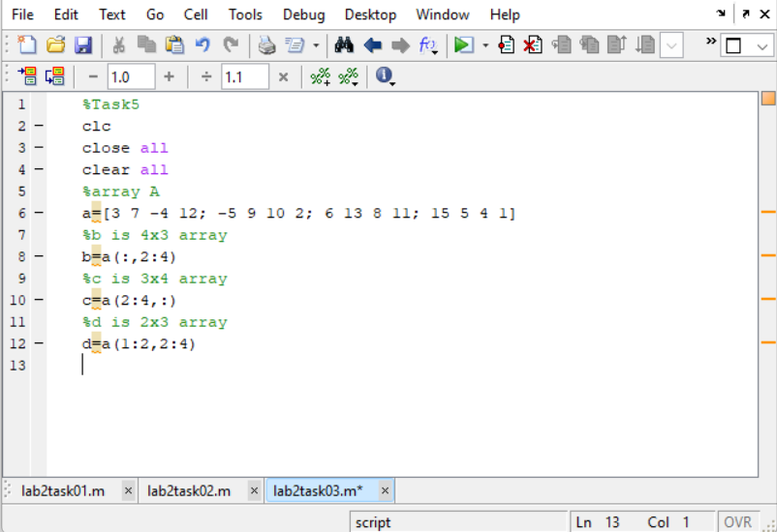

**Output:**

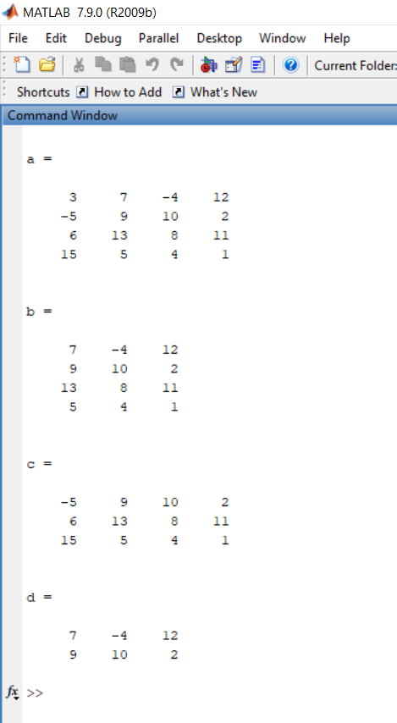

**Task 6:**

MATLAB has functions to round floating point numbers to integers. These are round, fix, ceil, and floor. Test how these functions work. Determine the output of the following: >> f = [‐.5 .1 .5]; >> round(f) >> fix(f) >> ceil(f) >> floor(f)

**Code:**

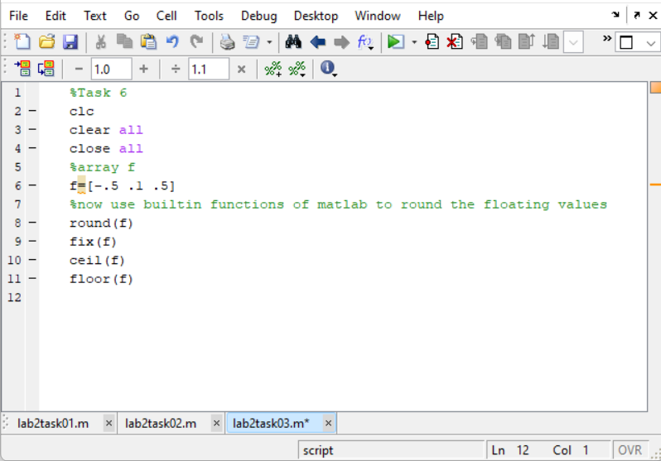

**Output:**

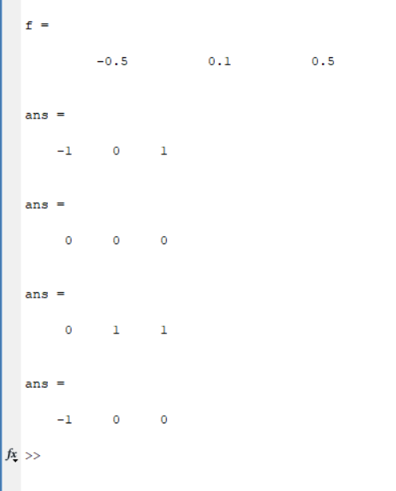

**Task 7:**

Given the following matrix:

−3 5 A = 4 8 Find the following:

1) Column‐wise sum of all elements of A using sum function; for information about sum function, type help sum in matlab

2) Column‐wise product of all elements of A using prod function; for information about prod function, type help prod in MATLAB

3) Length of matrix A 4) Size of matrix A

**Code:**

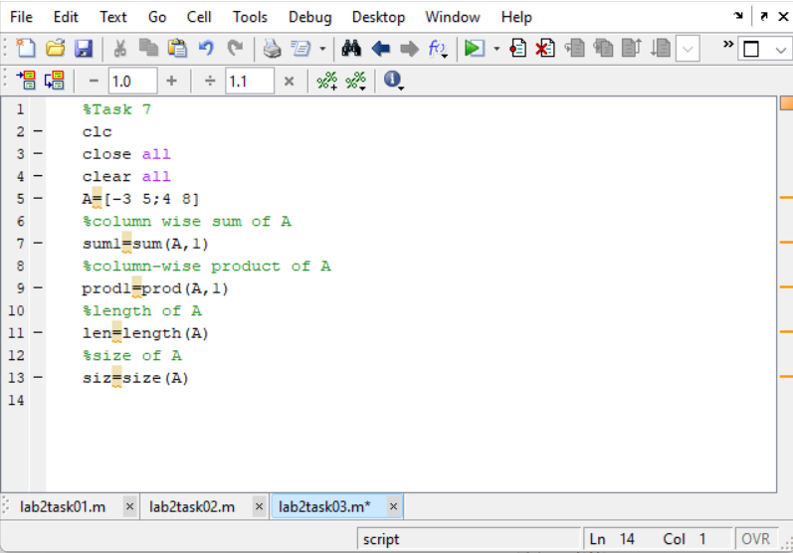

**Output:**

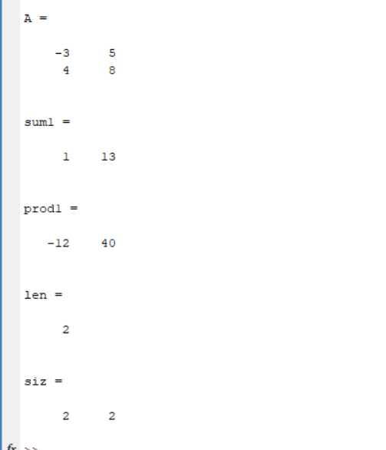

**Task 8:**

The end command is used to access the last row or column of a matrix. Use end command to delete and update the last row and column of the following matrix. Matrix A = [3 23 34 12 34 5 56 23; 12 34 34 32 23 23 45 1; 67 23 2 4 4 5 6 456; 4 5 1 1 2 34 45 56; 67 67 45 67 78 7 8 5; 6 35 5 3 5 56 7 8]

**Code:**

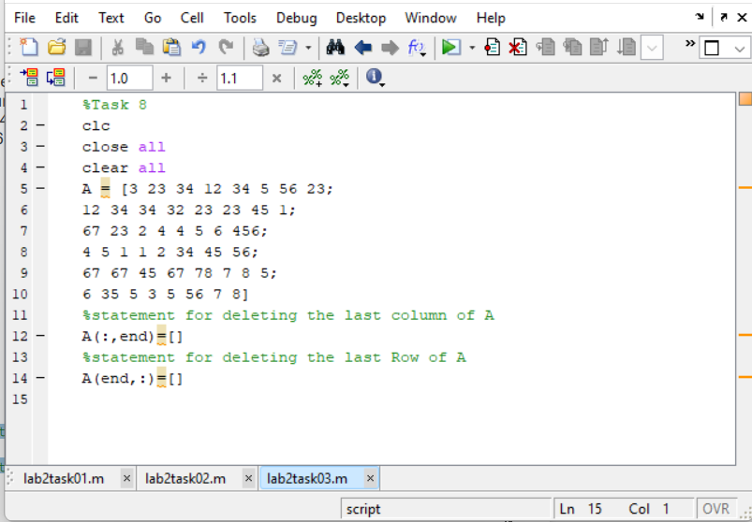

**Output:**

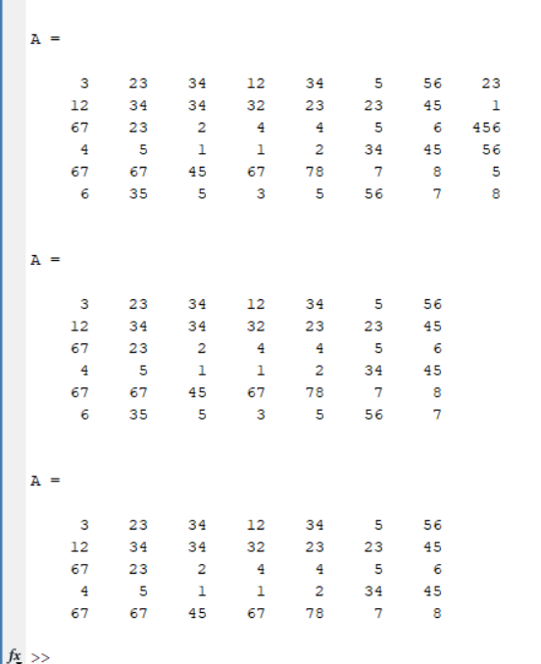

**Task 9:**

Try the following commands in MatLab and comment on them:

(i)A(3,end) (ii) A(:) (iii) A(: , end) (iv) Y = linspace(20,100) (v) Y = linspace(20,100,50)

**Code:**

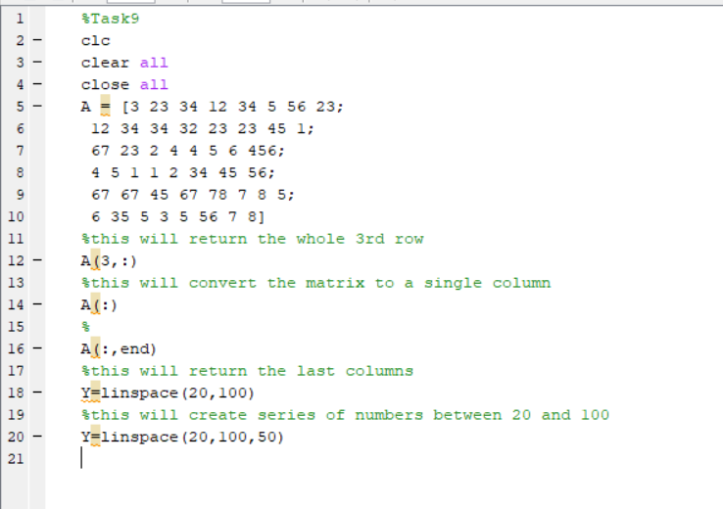

**Output:**

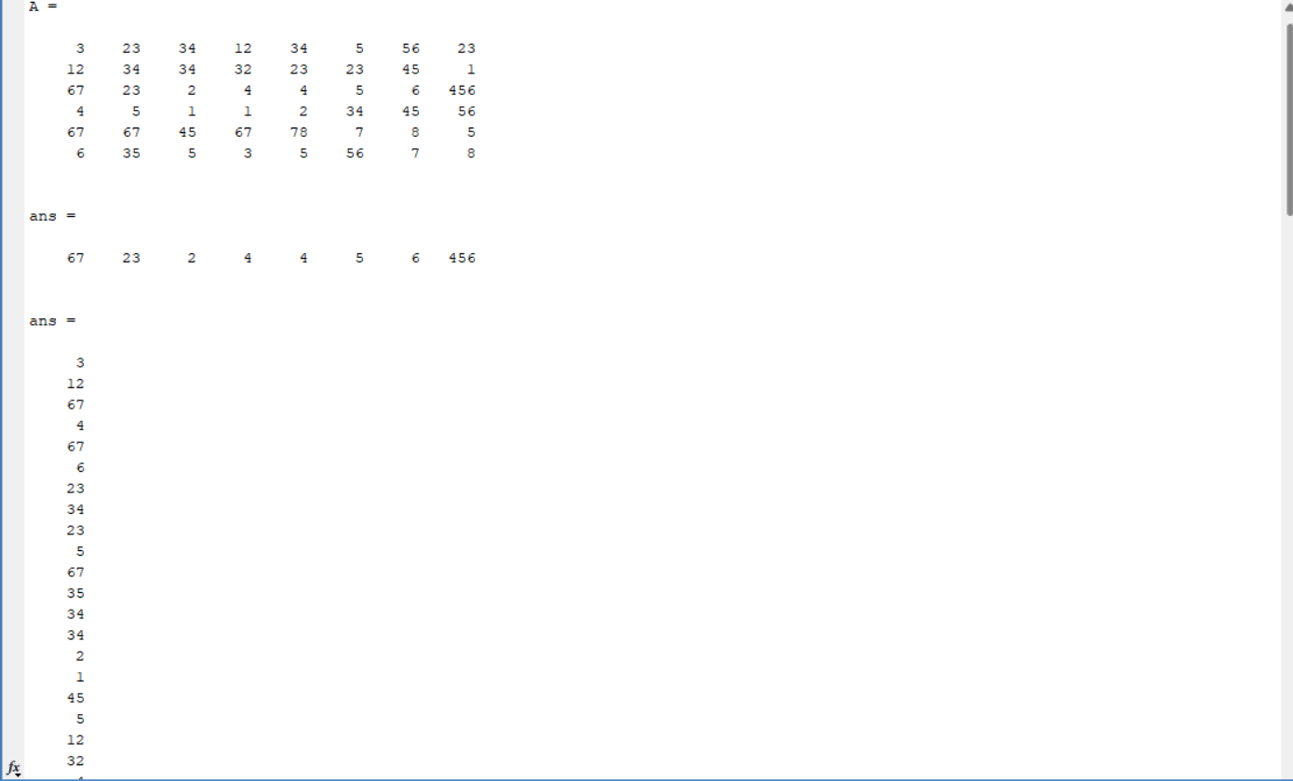

**Task 10:**

Use the inverse (inv(A)) function to find the inverse of A for finding the unknowns for Linear equation. x + 2y + 3z = 1 4x + 5y + 6z = 2 7x + 8y = 1

**Code:**

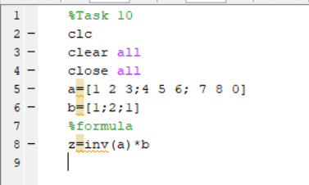

**Output:**

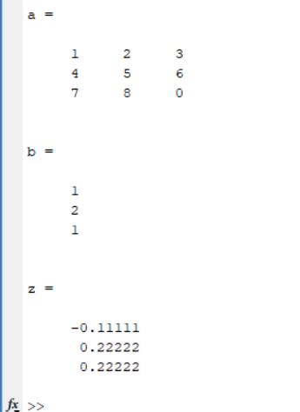

**Task 11:**

Solve Task 10 by taking the equations from user. Hint: Take the matrix A and b from user.

**Code:**

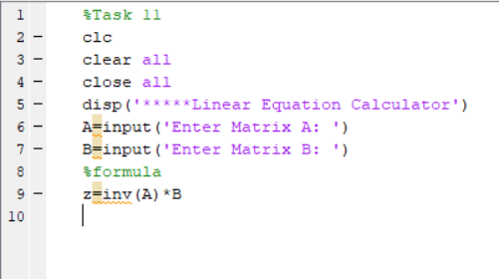

**Output:**

